Ideophones: Non-Arbitrariness and Reduplication

# Rationale

Ideophones- What do they do?

What do we know:

1. Ideophones appear to be easier to learn than non-ideophones
2. Ideophones are marked, distinct, etc.- there is something weird about them in terms of their structure phonotactically etc.

**One central question is whether or not these two features are related to each other? i.e. is it possible that ideophones are easier to learn because they are “weird”?**  
  
One answer to this question is of course “yes!”, but that’s an effect that we can trace to ***motivatedness*** – Ideophones are weird in the sense that they are motivated. But, are they also weird because their markedness is ***systematic***.

Some of the markedness of ideophones in Japanese appears obviously systematic- 35% of Japanese ideophones make use of reduplication- is there a reason for this?

(and of course these aren’t mutually exclusive):

## Three Possibilities for what reduplication is DOING (if anything)

### 1) Reduplication is, itself, iconic

This seems to be the case for some ideophones, certainly, where reduplication can reflect temporal or spatial dimensions

e.g. ‘gorogoro’ as a large object rolling.

In that case, the repetition of ‘goro’ appears to be iconic with regards to the fact that it describes a repeated action (rolling)

But what about other reduplicative ideophones?

e.g.‘iraira’ (angry)

This is further complicated by multiple construals of a word.

e.g. ‘fuwafuwa’ (fluffy) does not seem to have reduplication as an iconic cue, but if you think of it as meaning “the feeling when you pet the fur of a puppy” or something of the like, then suddenly it does

### 2) Reduplication is a (systematic) disambiguating cue

Can reduplication point to iconic constructions that are segment-internal and separate from any iconicity that is supplied by reduplication itself?

‘gorogoro’ has the iconic reduplication thing going on, but also some potential internal iconicity- i.e. the repeated use of the round vowel /o/ for a large, heavy object

Can reduplication thus be a systematic cue that flags a word as iconic?

### 3) Reduplication aids in memorability (but not based on either iconicity or systematicity)

This is a sensible alternative hypothesis- it suggests that reduplication can make learning easier without leveraging either iconicity or systematicity

Perhaps it doesn’t seem that likely, but it should at least be excluded (and it helps us look more closely at other possibilities)

The most straightforward explanation is that reduplication just doubles the amount of exposure to a segment, so it’s effectively twice as much “Training”

## What we already know

### Lockwood, Hagoort, & Dingemanse (2016)

Participants presented with pairs of ideophones and meanings that were either correct (congruent) or associated with the opposite meaning.

Done with both  
  
a) reduplicative ideophones (Experiment 1)

b) Normal adjectives (Experiment 2)

Reduplicative ideophones were easier to learn when paired with the correct meaning than with the incorrect one.

There was no similar difference for normal adjectives- i.e. it doesn’t matter whether you learn a normal adjective with its correct or opposite meaning.

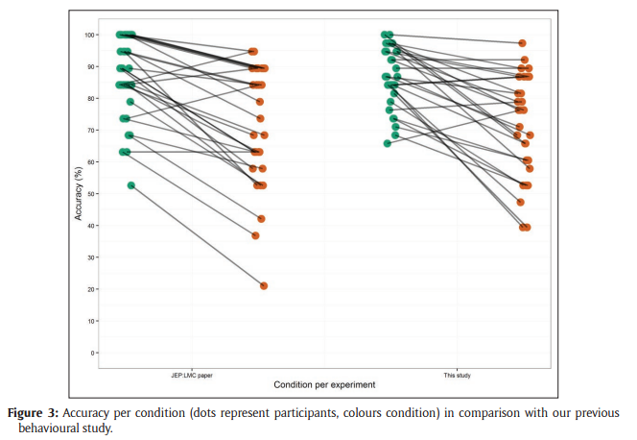

Ideophones are on the left graph. Normal adjectives are on the right.

#### What does this tell us?

Unfortunately, the results of the experiment can’t concretely disambiguate between our three explanations for what reduplication is doing

1. **Reduplication is, itself, iconic**
2. **Reduplication is a (systematic) disambiguating cue**
3. **Reduplication aids in memorability (but not based on either iconicity or systematicity)**

The only bit of explanation we get from the data is that 3 probably isn’t particularly likely as the only explanation, or else the reduplicative ideophones paired with opposite meanings would be learned better than normal adjectives  
  
(they don’t’ appear to be- but the adjective and ideophone learning are separate experiments and are not compared directly)

## How do we differentiate between our 3 possibilities?

How do we differentiate between the three possibilities?

Broadly, we need to introduce a number of additional types of words, both  
  
i) words that actually exist in the language in question (i.e. non-reduplicative ideophones)

And

ii) Artificially constructed words (e.g. split reduplicative ideophones)

#### 6 Word Types for experiment

1. Reduplicative ideophones (e.g. ‘fuwafuwa’)
2. Split reduplicative ideophones (e.g. ‘fuwa’)
3. Non-reduplicative ideophones (e.g. ‘shiin’ (silence))
4. Reduplicated non-reduplicative ideophones (e.g. ‘shiinshiin’)
5. Normal adjectives (e.g. ‘atsui’ (hot))
6. Reduplicated normal adjectives (e.g. ‘atsuiatsui’)

### Reduplication is, itself, iconic

Predictions:

1. Split reduplicative ideophones (B) should be learned worse than their reduplicative counterparts (A)
2. Reduplicated non-reduplicative ideophones (D) should not be learned any better than their normal counterparts (C)
3. Normal (E) and reduplicated normal adjectives (F) should be learned equally well to one another

### Reduplication is a (systematic) disambiguating cue

Predictions:

1. Split reduplicative ideophones (B) should be learned worse than their reduplicative counterparts (A)
2. Reduplicated non-reduplicative ideophones (D) should be learned better than their non-reduplicative counterparts (C)
3. Reduplicated (F) and normal adjectives (E) should be learned equally well

### Reduplication aids in memorability (but not based on either iconicity or systematicity)

Predictions:

1. All types of reduplication (A, D, F) should be learned better than their non-reduplicated counterparts (B, C, E

## Differentiating between hypotheses:

Some of the hypotheses support multiple explanations:

Split reduplicative ideophones (B) should be learned worse than their reduplicative counterparts (A)

Supports both:  
  
1) **Reduplication is, itself, iconic**

**2) Reduplication is a (systematic) disambiguating cue**

So, to some extent you need to rely on the outcomes of all predictions to tease these apart.  
  
i.e. if we find this result, do the rest of our findings align better with the two explanations (obviously, the results will never be that clean)

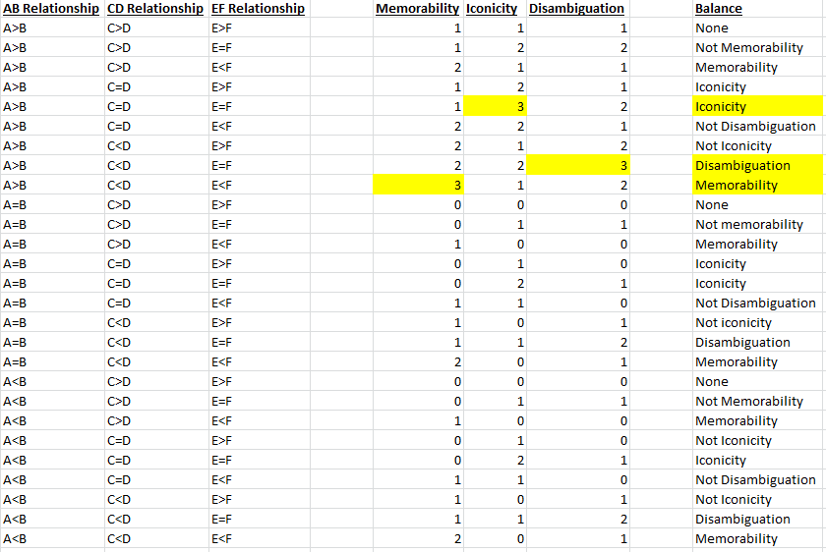

We now have this neat table of hypotheses and what the results of every combination of comparisons would be able to tell us. We're unlikely to get any of the three results that are least ambiguous (those highlighted in yellow), but any results other than those labelled "none" would be interesting and might point us towards future experiments.

# The Experiment

## Design

Basic design as per Lockwood, Hagoort, & Dingemanse (2016)  
Training

"The initial Dutch word was presented for 1000ms with 100ms of jitter each way (i.e. between 900ms and 1100ms), followed by a fixation cross for 1000ms with 100ms of jitter. As the ideophone was played over the speakers, a blank screen was presented for 2000ms with 200ms of jitter. This was again followed by a fixation cross. The final screen with the ideophone and its Dutch meaning was presented until participants were happy to move onto the next item. Between trials, a blank screen was presented for 1000ms with 200ms of jitter, followed by a fixation cross for 1000ms with 100ms of jitter to announce the beginning of the next trial."

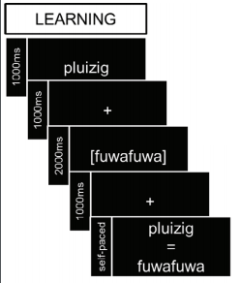

### Testing

When it came to the test round, participants were presented with either the word pairs that they had learned (for example, fuwafuwa and pluizig in the real condition, and kibikibi and futloos in the opposite condition), or a pseudo-randomised pairing of ideophones and translations which they had seen before. These pairings were pseudo-randomised to ensure that the meanings were semantically unrelated (for example, the Japanese fuwafuwa, learned as “fluffy”, and the Dutch kortaf, meaning “curt”). Participants were instructed to indicate whether this was a word pair they had learned by answering Yes (left CTRL key) or No (right CTRL key). Pairs requiring a Yes response made up 50% of the trials. As in the learning round, participants saw the Dutch word first, then heard the Japanese ideophone for 2000ms. Then, instead of seeing a fixation cross, they saw a question mark. Participants were asked to respond as soon as possible after seeing the question mark. Timings in the test stage were identical to the learning stage. The question mark was displayed until participants responded, at which point a blank screen was presented, followed by a fixation cross to announce the beginning of the next trial. In order to ensure enough trials for ERP analysis, the test stage was twice as long as in Lockwood et al. [11], so that there were 38 trials per condition (i.e. 19 ideophones with their real translation, 19 ideophones with their opposite translation, and 38 ideophones with a pseudo-randomised wrong translation, all repeated).

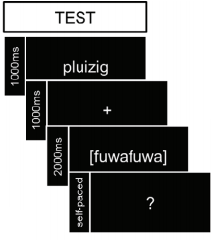

### 2AFC Task

After the test round, we implemented a two-alternative forced choice task as a separate measure of sound-symbolic sensitivity. This was to see if, despite the learning phase, participants were still able to make decisions based on the sound symbolism of the ideophones. Participants heard the ideophone, and then saw the two possible Dutch translations; they selected the translation by pressing the left CTRL key for the translation on the left and the right CTRL key for the translation on the right. Timings were identical to the learning and test stages.

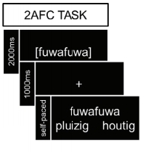

## Stimuli

All Japanese words in CVCV pattern (CVCV-CVCV for reduplicated versions)

6 types of words for this experiment  
  
A) Reduplicative Ideophones (RI)  
B) Split Reduplicative Ideophones (SRI)  
C) Non-Reduplicative Ideophones (NRI)  
D) Reduplicated Non-Reduplicative Ideophones (RNRI)  
E) Normal Adjectives (NA)  
F) Reduplicated Normal Adjectives (RNA)

### Meanings

We have sets of the following meaning types: A, B,E,F   
We need C,D

### Translations

I have put in some preliminary English translations for the meanings that we already have. It would probably be best for Mits to take a first bash at the translations for everything.

### Controls:

#### Control for word frequency of translations?

This is not necessary if we do not make use of both congruent and incongruent mappings.

#### Counterbalancing and randomization

##### Semantics-

Lockwood et al. pseudo randomize testing such that meanings were semantically unrelated.  
  
I do not think this is a necessary control, but something we can include in the analysis, provide we have an easy to use measure of semantic relatedness.

##### Randomization of real vs. opposite

Obviously this is only relevant if we make use of congruent vs. incongruent mappings.  
I believe it's most sensible to randomize these mappings- this allows subsequent analysis of the differences for individual meanings between participants.

## Remaining Design Questions

### Meanings

#### Congruent Meanings only

20 words of each of 3 word types (reduplicative ideophones, non-reduplicative ideophones, normal adjectives)  
  
Half of each word list learned as original type (10), half learned as reduplicated/split version

#### Congruent and Incongruent Meanings

20 words of each 3 word types  
  
Half of each word list learned as original, half learned as reduplicative/split version (10)

Half of each of those lists learned congruently (5), half learned incongruently (5)

### Testing and Distractors

It's possible to use either one of these types of foils or both

#### Random Foils

Lockwood et al. use pseudorandom foils. This is one way to go.

#### Antonym Foils

Including antonym foils is somewhat like the subsequent 2AFC task, but come at the issue slightly differently. It might be interesting if participants believe they have been taught antonyms (especially when the "antonym" of the meaning they learned is actually the correct one.

## Possible Experiment Configurations

|  |  |  |  |  |  |  |  |  |  |  |  |  |  |  |  |  |  |  |  |  |  |  |
| --- | --- | --- | --- | --- | --- | --- | --- | --- | --- | --- | --- | --- | --- | --- | --- | --- | --- | --- | --- | --- | --- | --- |
|  | **TRAINING** | | | | | | | | | | |  | **TESTING** | | | | | | | | | |
|  | Congruent Meanings | | | | | | Incongruent Meanings | | | | |  |  | | |  | |  | |  |  | |
|  | A-  RI | B-  SRI | C-  NRI | D-  RNRI | E-  NA | F-  RNA | A-  RI | B-  SRI | C-  NRI | D-  RNRI | E-  NA | | | F-  RNA |  | | %  Targets | | %  Random | | %  Antonym | | | Total  Testing  Trials |
| **1** | 10 | 10 | 10 | 10 | 10 | 10 | - | - | - | - | - | | | - |  | | 100 | | 100 | | 100 |  | | 180 |
| **2** | 10 | 10 | 10 | 10 | 10 | 10 | - | - | - | - | - | | | - |  | | 100 | | 100 | | 0 |  | | 120 |
| **3** | 10 | 10 | 10 | 10 | 10 | 10 | - | - | - | - | - | | | - |  | | 100 | | 0 | | 100 |  | | 120 |
| **4** | 10 | 10 | 10 | 10 | 10 | 10 | - | - | - | - | - | | | - |  | | 33 | | 33 | | 33 |  | | 60 |
| **5** | 10 | 10 | 10 | 10 | 10 | 10 | - | - | - | - | - | | | - |  | | 50 | | 50 | | 0 |  | | 60 |
| **6** | 10 | 10 | 10 | 10 | 10 | 10 | - | - | - | - | - | | | - |  | | 50 | | 0 | | 50 |  | | 60 |
|  |  |  |  |  |  |  |  |  |  |  |  | | |  |  | |  | |  | |  |  | |  |
| **7** | 5 | 5 | 5 | 5 | 5 | 5 | 5 | 5 | 5 | 5 | 5 | | | 5 |  | | 100 | | 100 | | 100 |  | | 180 |
| **8** | 5 | 5 | 5 | 5 | 5 | 5 | 5 | 5 | 5 | 5 | 5 | | | 5 |  | | 100 | | 100 | | 0 |  | | 120 |
| **9** | 5 | 5 | 5 | 5 | 5 | 5 | 5 | 5 | 5 | 5 | 5 | | | 5 |  | | 100 | | 0 | | 100 |  | | 120 |
| **10** | 5 | 5 | 5 | 5 | 5 | 5 | 5 | 5 | 5 | 5 | 5 | | | 5 |  | | 33 | | 33 | | 33 |  | | 60 |
| **11** | 5 | 5 | 5 | 5 | 5 | 5 | 5 | 5 | 5 | 5 | 5 | | | 5 |  | | 50 | | 50 | | 0 |  | | 60 |
| **12** | 5 | 5 | 5 | 5 | 5 | 5 | 5 | 5 | 5 | 5 | 5 | | | 5 |  | | 50 | | 0 | | 50 |  | | 60 |

Here is a (badly formatted) table of some possible configurations of the experiment and their resultant number of trials.  
  
%Target, % Random, and % Antonym refer to the percentage of meanings that will be seen with each type of target/distractor in the testing phase. Thus for configuration 1 each meaning is seen a total number of 3 times- once as a target (how it is learned, be that congruently or incongruently), once with its antonym, and once with a random (or pseudorandom) meaning.